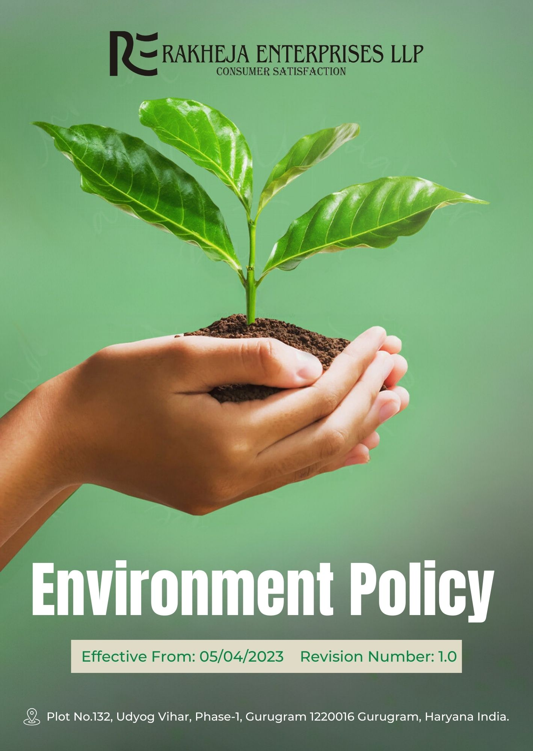
Table of Contents
1. Introduction 3
2. Planned objectives 3
3. Scope 3
4. Rakheja’s Environmental key strategies and targets 4
5. Responsibility 8
6. Reporting 9
7. Continuous Improvement 9
8. Review Cycle 10
9. Acknowledgement by Employee 11

Introduction
At Rakheja Enterprises LLP, we are deeply committed to environmental stewardship and sustainable development. Our operations recognize the significant impact textile manufacturing and transportation activities can have on the environment, and we are dedicated to mitigating these impacts through proactive measures and continuous improvement. We believe that sustainable practices are not only essential for the well-being of our planet but also for the longevity and success of our business. Our environmental policy outlines our commitment to reducing our carbon footprint, conserving natural resources, and promoting sustainable products. By integrating environmental considerations into every aspect of our operations, including but not limited to textile production, finishing, and transportation, we aim to lead by example in the textile industry and contribute to a more sustainable future.

Planned objectives
- To minimize the environmental impact of our operations through efficient resource management and waste reduction.
- To promote sustainable practices and products within the textile manufacturing and transportation industry.
- To ensure compliance with all relevant environmental regulations and standards.
- To engage and educate employees, stakeholders, and customers on the importance of environmental responsibility.
- To integrate renewable energy sources and technologies to reduce reliance on non-renewable resources and lower overall carbon footprint.
- To foster innovation and continuous improvement in environmental performance by setting measurable targets and regularly reviewing progress.

Scope
This Policy applies to all employees (at all levels), stakeholders (internal and external), partners, contractors, customers, suppliers, and any other individual or entity working on behalf of Rakheja Enterprises LLP. It also applies to all our manufacturing facilities.

Rakheja’s Environmental key strategies and targets
- Energy Efficiency:
- We are deploying energy-efficient LED lighting systems throughout our manufacturing facilities and warehouses. For achieving a 10% reduction in energy consumption by FY 2025-26 from the baseline FY 2022-23, this is our primary focus.
- By upgrading to high-efficiency electric motors and variable frequency drives in our textile machinery, we aim to reduce energy usage by 12% by FY 2025-26 from the baseline FY 2022-23.
- We are installing heat recovery systems in dyeing and finishing processes to capture and reuse waste heat. Our target is to lower overall energy consumption by 6% in these areas by FY 2025-26 from the baseline FY 2022-23.
- Renewable Energy:
- We are installing rooftop solar panels on our facilities and warehouses to generate renewable energy. Our target is to meet 15% of our electricity needs from solar power by FY 2025-26 from the baseline FY 2022-23.
- To transition to electric vehicles for short-haul deliveries, we are focusing on this shift. We aim for 50% of our local delivery fleet to be electric by FY 2025-26 from the baseline FY 2022-23.
- Water Management & Wastewater Reduction:
- We are installing ultrafiltration and reverse osmosis systems in our dyeing and finishing units to facilitate water recycling. Our goal is to recycle 14% of process water by FY 2025-26 from the baseline FY 2022-23.
- We are installing advanced water management systems and adopting water-saving technologies to lower water usage. We aim to achieve a 15% reduction in fresh water consumption by FY 2025-26 from the baseline FY 2022-23.
- Adopting waterless dyeing technologies, such as supercritical CO2 dyeing, is our focus. We aim to cut water usage in dyeing processes by 12% where applicable by by FY 2025-26 from the baseline FY 2022-23.
- Waste Reduction
- We are launching a fabric scrap recycling initiative to convert textile waste into recycled fibers. Our target is to recycle 25% of fabric scraps by FY 2025-26 from the baseline FY 2022-23.
- Introducing a packaging take-back program for B2B clients is a key strategy. We aim to reuse or recycle 20% of returned packaging materials by FY 2025-26 from the baseline FY 2022-23.
- We are introducing recycling programs and optimizing our production processes to minimize waste. Our aim is to achieve a 15% reduction in overall waste by FY 2025-26 from the baseline FY 2022-23
- Effective Management of Chemicals and Raw Materials:
- We are transitioning to GOTS (Global Organic Textile Standard) certified organic dyes and chemicals. Our goal is to increase their use by 10% by FY 2025-26 from the baseline FY 2022-23.
- Implementing a digital chemical management system ensures compliance with ZDHC (Zero Discharge of Hazardous Chemicals) guidelines. We aim for 100% adherence by FY 2025-26 from the baseline FY 2022-23.
- Introducing enzyme-based treatments in our fabric finishing processes is a focus. We aim to reduce chemical usage by 7 to 8% by FY 2025-26 from the baseline FY 2022-23.
- Greenhouse Gas Reduction:
- We are concentrating on enhancing energy efficiency, increasing renewable energy use, and optimizing transportation routes to address GHG emissions comprehensively. Our goal is to reduce Scope 1, 2, and 3 GHG emissions by 10% by FY 2025-26 from the baseline FY 2022-23.

- Biodiversity Preservation
- We have implemented a habitat restoration program that includes creating buffer zones along our facilities to protect local wildlife, targeting a 20% improvement in habitat quality by FY 2025-26 from the baseline FY 2022-23.
- We are actively monitoring and reducing our impact on local ecosystems through regular biodiversity assessments, with a goal to decrease our ecological footprint by 10% by FY 2025-26 from the baseline FY 2022-23.
- Air Pollution Prevention
- We are focusing on reducing air pollution by installing advanced filtration systems in our manufacturing facilities, aiming for a 30% reduction in particulate emissions by FY 2025-26 from the baseline FY 2022-23.
- To achieve a 25% decrease in volatile organic compounds (VOCs) emissions, we are implementing low-emission technologies and optimizing our production processes by FY 2025-26 from the baseline FY 2022-23.
- Our ongoing efforts to control air pollution include regular maintenance and upgrading of emission control systems to ensure compliance with air quality standards and achieve a 15% reduction in overall emissions by FY 2025-26 from the baseline FY 2022-23.
- Noise and Odor Pollution
- We are focusing on reducing noise pollution by implementing advanced soundproofing measures in our production areas, aiming to achieve a 30% reduction in noise levels by FY 2025-26 from the baseline FY 2022-23.
- To address odor pollution, we are installing state-of-the-art filtration systems in our textile processing units, targeting a 40% decrease in odor emissions by FY 2025-26 from the baseline FY 2022-23.
- Ecological Impacts of Product Utilization and End of use
- Our aim is to decrease the environmental footprint of our textiles throughout their entire lifecycle, achieving a 15% reduction by FY 2025-26 from the baseline FY 2022-23.
- We have embedded eco-design principles into our textile manufacturing practices, striving to achieve a 20% reduction in environmental impact by FY 2025-26 compared to FY 2022-23.
- We provide comprehensive end-of-life support for our textiles, including take-back programs, to reduce waste from discarded textiles by 10% by FY 2025-26 from the baseline FY 2022-23.
- We are increasing our use of sustainable materials, such as organic cotton and natural dyes, targeting a 20% rise in the use of these materials by FY 2025-26 from the baseline FY 2022-23.
- Customer Health and Safety
- We are committed to incorporating non-toxic dyes and materials in our textiles, targeting a 30% increase in the use of safer substances by FY 2025-26 from the baseline year FY 2022-23.
- By providing clear and comprehensive care instructions for our textiles, we aim to reduce misuse and related health risks, achieving a 25% decrease in such incidents by FY 2025-26 from the baseline year FY 2022-23.
- To enhance safety, we continuously monitor and evaluate our textile products, aiming to meet and surpass all relevant safety standards by FY 2025-26 from the baseline year FY 2022-23.
- To ensure customer safety, we have implemented rigorous quality control measures, including ISO 9001 certification, with a goal to reduce product-related health incidents by 20% by FY 2025-26 from the baseline year FY 2022-23.
- Environmental Services and Advocacy
- We are committed to providing specialized environmental consulting services tailored to the textile sector, helping our clients evaluate and reduce their ecological impacts, with a target of We aim to provide specialized environmental consulting services to 30 merchants by FY 2025-26 from the baseline FY 2022-23.
- We have launched an advanced textile impact assessment tool that offers in-depth analysis and recommendations for minimizing water usage and chemical discharge, aiming for a 15% enhancement in sustainability practices within the textile manufacturing process by FY 2025-26 from the baseline FY 2022-23.

Responsibility
- Board of Directors
- Set the strategic direction for the environmental strategy.
- Ensure alignment with business objectives and sustainability targets.
- Approve major environmental initiatives.
- Review performance reports.
- Environmental Management Committee
- Oversee implementation of the environmental strategy.
- Develop and execute environmental programs.
- Set performance targets and monitor progress.
- Report to the Board of Directors.
- Composed of senior management from production, supply chain, and HR.
- Environmental Officer
- Implementation, oversight and Review of this Environmental Policy
- Manage day-to-day environmental initiatives.
- Coordinate program execution.
- Ensure regulatory compliance.
- Prepare performance reports for the Environmental Management Committee.
- Department Heads
- Ensure departmental compliance with the environmental strategy.
- Integrate environmental practices into operations.
- Train staff on sustainable practices.
- Report progress to the Environmental Officer.
- Employees
- Follow environmental guidelines.
- Participate in training sessions.
- Contribute to achieving sustainability targets.

Reporting
Transparent and regular reporting is crucial for tracking progress, identifying improvement areas, and ensuring accountability. Rakheja Enterprises LLPimplements the following reporting procedures:
- Regular Environmental Performance Reports: We perform annual evaluations of our environmental performance, collecting data on key metrics specified in our Environmental Strategy.
- Internal Audits: We conduct internal audits to assess compliance with environmental regulations, evaluate the effectiveness of our environmental management systems, and pinpoint areas needing corrective action.
- Stakeholder Engagement: We actively engage with stakeholders, including employees, customers, regulators, and local communities, to obtain feedback, address concerns, and communicate our environmental performance and initiatives clearly.

Continuous Improvement
At Rakheja Enterprises LLP, we are dedicated to continuously enhancing our environmental performance. We will regularly review and refine our environmental strategies to adapt to evolving challenges and opportunities. Our commitment includes setting and updating measurable targets, integrating feedback from internal and external stakeholders, and adopting the latest technologies and best practices. We will conduct periodic assessments of our environmental programs and practices, ensuring that our initiatives remain effective and aligned with our sustainability goals. Continuous training and development will be provided to employees to foster a culture of environmental stewardship. By promoting innovation and encouraging proactive participation, we strive to exceed our targets and drive sustainable progress across all aspects of our operations. Our goal is to embed continuous improvement into our core business processes, ensuring that our environmental practices remain dynamic, impactful, and forward-thinking.

Review Cycle
The Environmental Officer will review this policy every two years to ensure it remains effective and relevant. The review will cover regulatory compliance, progress towards objectives, and stakeholder feedback. Any necessary updates will be made to address emerging challenges and opportunities, ensuring continuous improvement in our environmental performance.
Prepared By (Name) | Environmental officer
Date of Preparation | 27/03/2023
Prepared by (Signature)
Approved By | General Manager
Date of Approval | 31/03/2023
Signature of Approver
Implementation Date | 05/04/2023
Next Review Date | 01/04/2025

Acknowledgement by Employee

I acknowledge that I have received, read, and understood the Environmental Policy of Rakheja Enterprises LLP. I am aware of the company’s deep commitment to environmental stewardship and the specific objectives and strategies outlined in the policy. I understand my responsibilities in contributing to our environmental goals, including adherence to the guidelines, participation in required training, and support for sustainability initiatives. I agree to diligently follow the policy and actively assist in achieving the set targets. I also recognize that ongoing compliance and active participation are crucial for our collective success in maintaining high environmental standards. I commit to proactively seeking opportunities to enhance our environmental practices and to report any issues, concerns, or suggestions for improvement to my supervisor or the Environmental Officer.
Employee Name
Acknowledgement Date
Signature

